WEX HEATLH CLOUD COBRA & DIRECT BILLING MEMBER PROTAL QUICKSTART QUIDE

Welcome to your Innovative Business Consultants COBRA & Direct Billing Portal. This one-stop portal gives you 24/7 access to view information and manage your COBRA & Direct Billing plans. It enables you to:

- Enroll in coverage
- Make a payment
- Review payment history and upcoming payments
- Review personal information

HOW DO I LOG ON?  - You should have received a New Member Login Notice containing your registration code. If you have not received a New Member Login Notice please contact your administrator at 712-277-2424  - Go to cobrapoint.benaissance.com and select New User Registration.  - Enter your registration ID and SSN, then submit registration.  - Accept the New User License Agreement.  - Set up your username and password.  - Click Submit & Create Account.  HOW DO I ENROLL?  - After registration, if you have not submitted an enrollment form, you will be directed to enroll in your COBRA benefits.  - You will be able to choose the products that you wish to elect as well as the coverage level for each product.  - Once you have completed your election you will be directed to your member portal Home Page.  The Home Page is easy to navigate:  - Setup your payments directly with the Make Payment button.  - Review your payment schedule, summary, and history from the payment info selection.  - Review your personal information via the profile selection.  - Update your login and communications options in the preferences selection.  - Review all information sent on your account in the communications and messages selections.  - Review your election, including coverage level and amount in the election selection. |  | 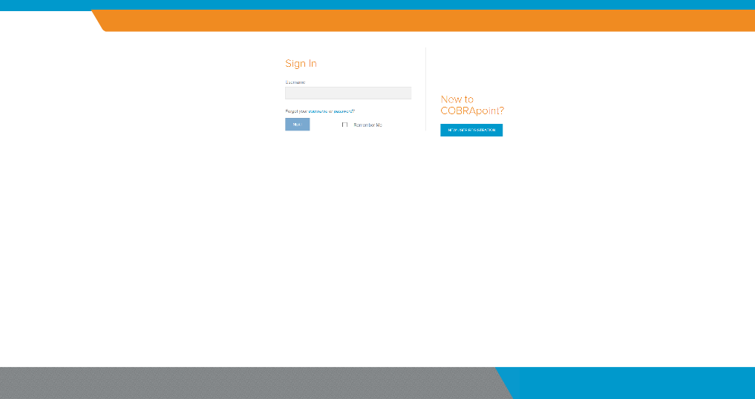  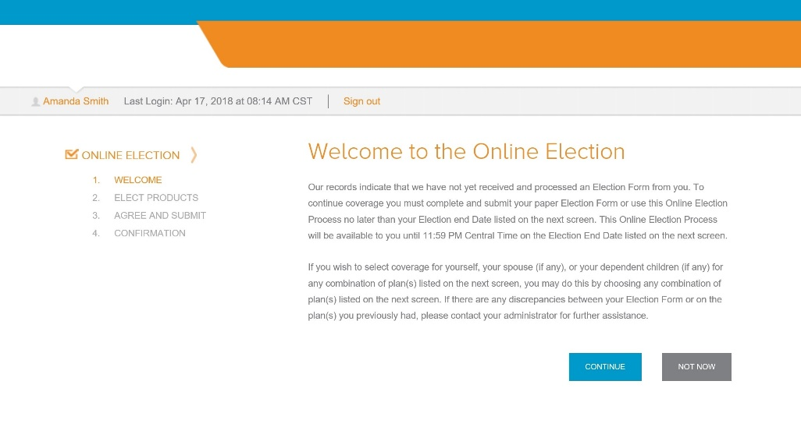  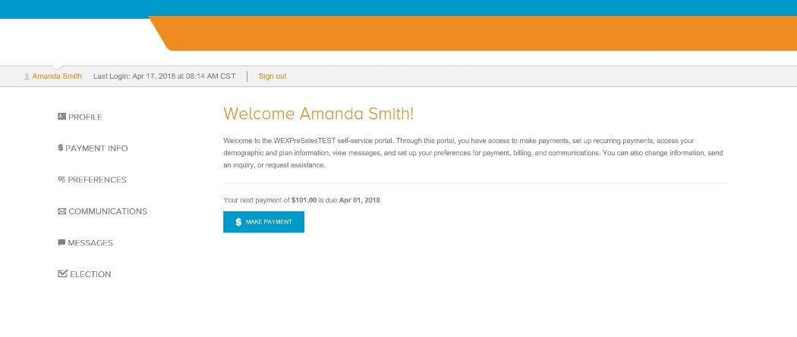
HOW DO I MAKE A PAYMENT?  - The option to make a payment is available from the Make Payment button on both the home page as well as the Payment Summary page under the Payment Info selection.  - Select between paying via Card, Bank Account, or Check through the mail.  - The check option will take you to the form to be printed and mailed with your check. Otherwise, you will be prompted to select the amount to pay, and notified of any applicable fees.  - Finally, complete the payment info fields before reviewing and submitting your payment. | 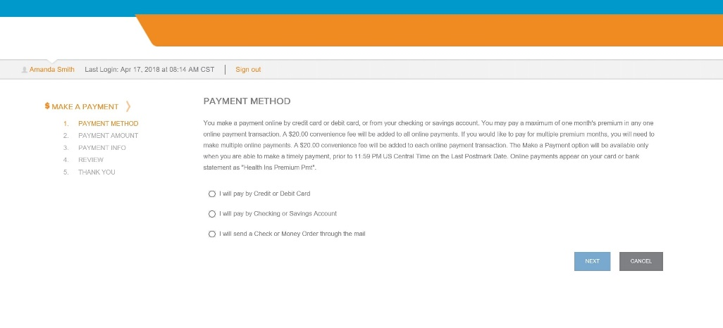

HOW DO I MAKE A RECURRING PAYMENT  - The Recurring Payments option is available from the home page and under the payment info options.  - Select between setting up electronic payments or payments via mail.  - Selecting electronic payments will bring you to a screen to fill in your bank account information, while selecting payments via mail will provide you a link to download the Automatic Premium Payment form.  - After completing the payment info fields click NEXT to submit your recurring payment. | 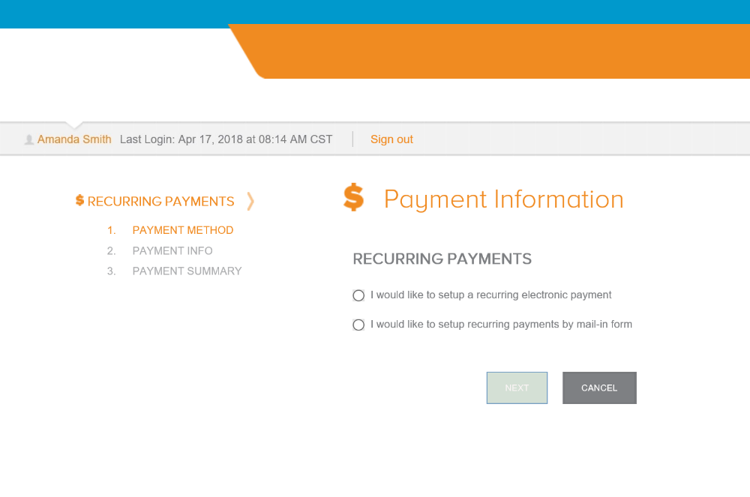
HOW DO I REVIEW PAST PAYMENTS?  - Past payments can be reviewed from the Payment Info selection.  - The payment schedule shows payments that have been made, what your next payment is, and your payment schedule after that.  - The payment summary shows, in brief, the last payment made and the next payment to be made, as well as providing the option to make a payment.  - The payment history shows each payment that has been made as separate line items. | 