Welcome to Innovative Business Consultants WEX Health Cloud COBRA & Direct Billing Employer Portal. This one-stop portal gives you the tools you need to better support your members in the management of their COBRA benefit plans.

The COBRA & Direct Billing Employer Portal is convenient and easy to use. Any-time access to the portal allows you to:

- Add members and member events
- View real-time individual participant account summary, plans, and payments
- View current and prior year plan information
- Retrieve reports generated by the employer
- Load data files
- Access comunication history

HOW DO I GET ACCESS TO THIS PORTAL?  - You will be sent a New Client Login notice containing a registration code.  - Navigate to cobrapoint.benaissance.com and select New User Registration.  - When going through New User Registration, you will be prompted to enter your registration code and company EIN, and then set up a password.  - Once a password is created and confirmed, you will be automatically directed to your Home page.  - For any subsequent logins, you will enter your username on the main login page and then enter your password on a secondary login page.  The Home page is easy to navigate:  Once you’re logged in, everything you need to efficiently and effectively manage your COBRA accounts is found on the Home page. From the Home page, you can:  - Add a new member  - View member-level data  - Check the status of file imports  - View plan information  - Import files  - View communications  The options within the left navigation Main Menu will direct you to any action you need to take. | 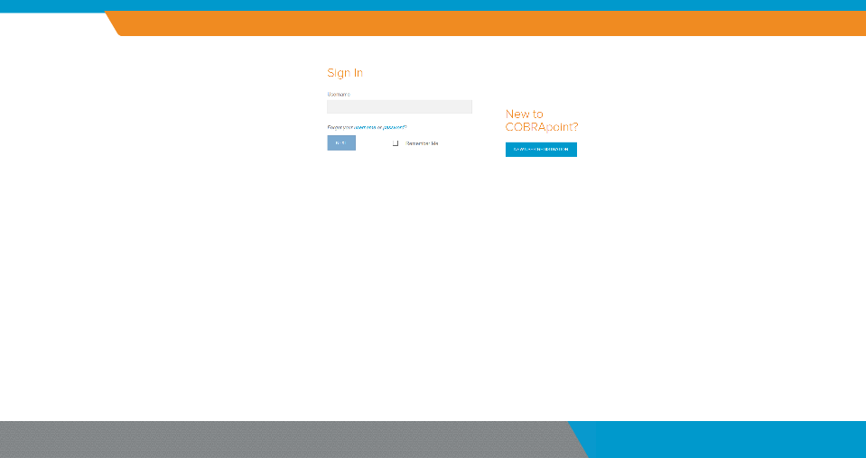  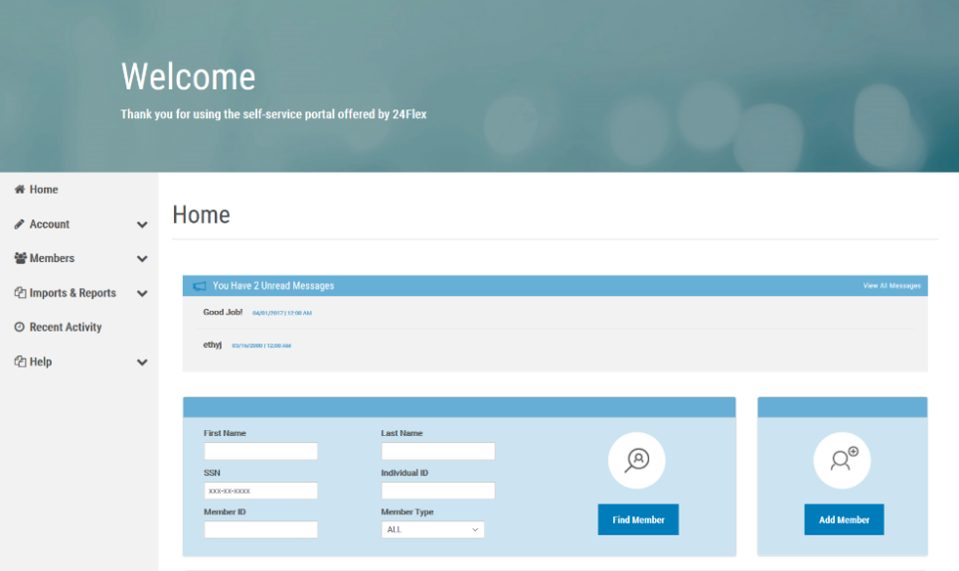
WHAT KIND OF MEMBER-LEVEL DATA CAN I ACCESS?  - You can locate a member’s record using the Find Member option available on the Home page or from the Members menu option.  - You can search for members using first name, last name, SSN, Individual ID, Member ID, as well as Member Type.  - Once in the member view, you can access the following information:  - Demographics  - Event Information  - Payments  - Plan Enrollments  - Communications  - Letter Attachments  HOW DO I VIEW AND REQUEST REPORTS?  - Select the Imports & Reports option to expand it and show the Accounting Reports and Standard Reports options.  - After selecting either report option, you will be provided with a drop-down menu to choose which report you would like to generate.  - Complete the required fields, marked with a red asterisk, and click the Run Report button.  - The report will generate and be available in the Job Queue.  - At the bottom of the page for the chosen report, you are also able to schedule a report for a given date and time, as well as allow the report to generate continuously on a schedule.  ONE OF THE FEATURES OF THE PORTAL IS THE ABILITY TO IMPORT DATA. HOW DOES THAT WORK?  - Select the Imports & Reports option to expand it and show the Imports option.  - After selecting the Imports option, you can import demographic, dependent, event, and plan information into the portal using standard CSV formatted import files.  - Import Specifications, used in the creation of your import file, are available on the page.  - Results will be available in the Job Queue. |  | 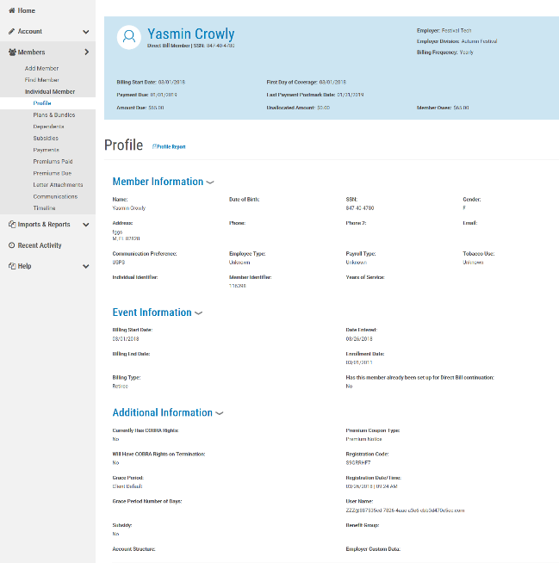  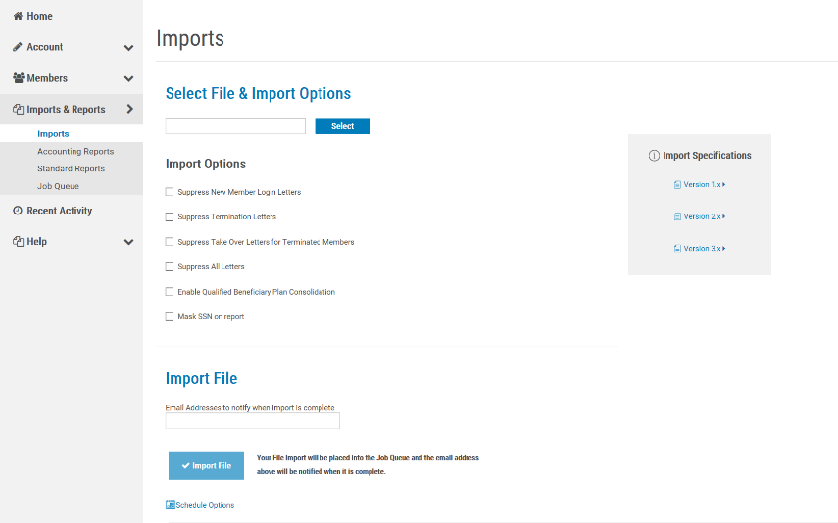  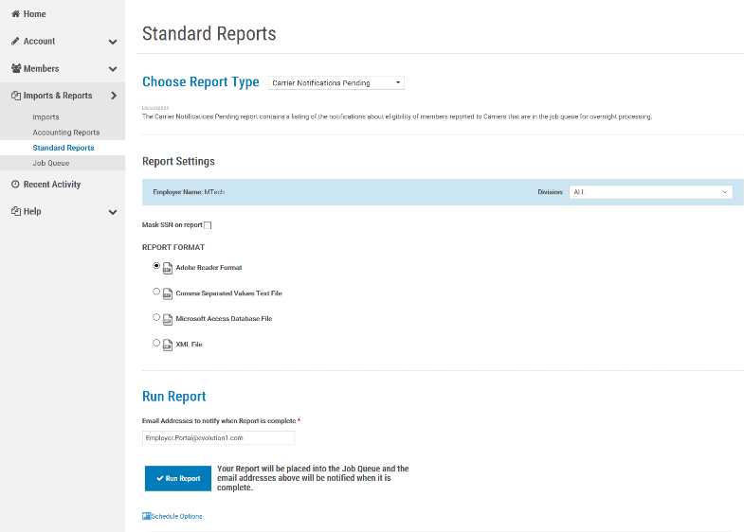

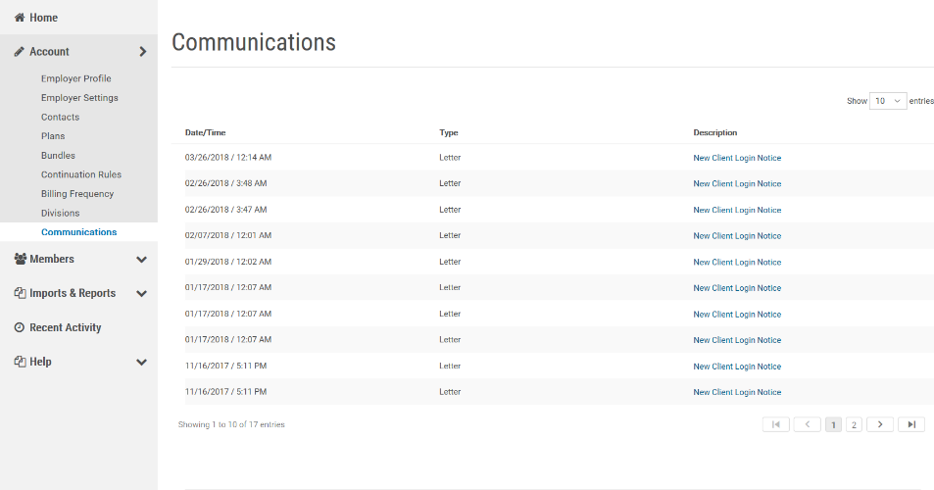

HOW DO I VIEW COMMUNICATIONS AND MESSAGES?
- Select the Account option to expand it and show the Communications option.
From the Communications page you can view the communcations provided specifically for you. In addition, selecting the Communications option once you’ve located a member and are in the member view, allows you to view the communications provided for the member

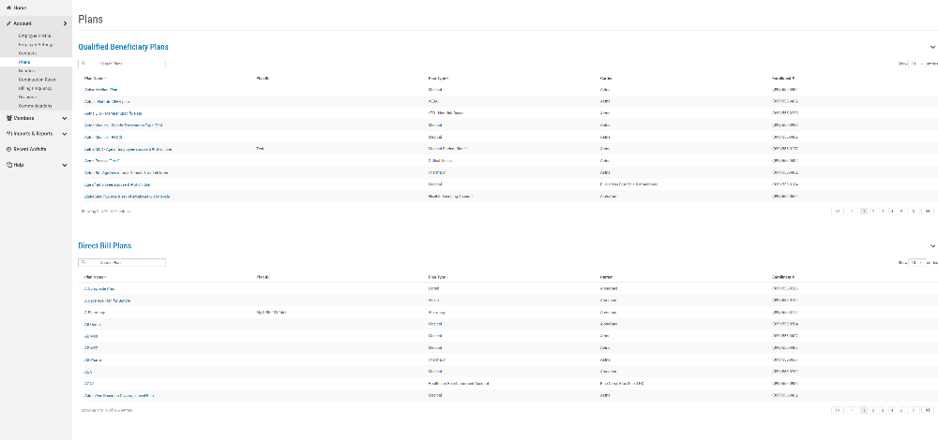
WILL I BE ABLE TO ACCESS ANY OF MY PLAN INFORMATION?
- Select the Account option to expand it and show the Plans and Bundles options.
- Selecting either option will display the plans or bundles for Qualified Beneficiary and Direct Bill members.
- Information available includes:
- Carrier Information
- Rates
- Plan Settings

